1. **In build server configure Ansible manually**

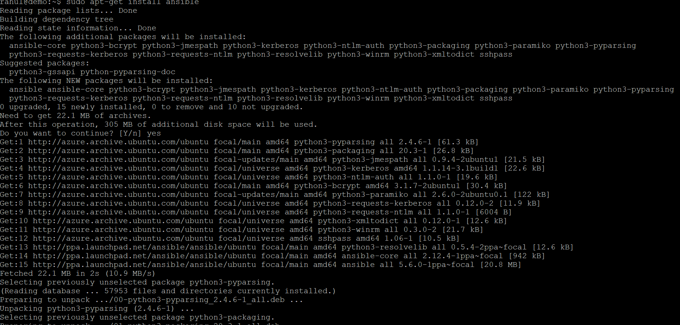

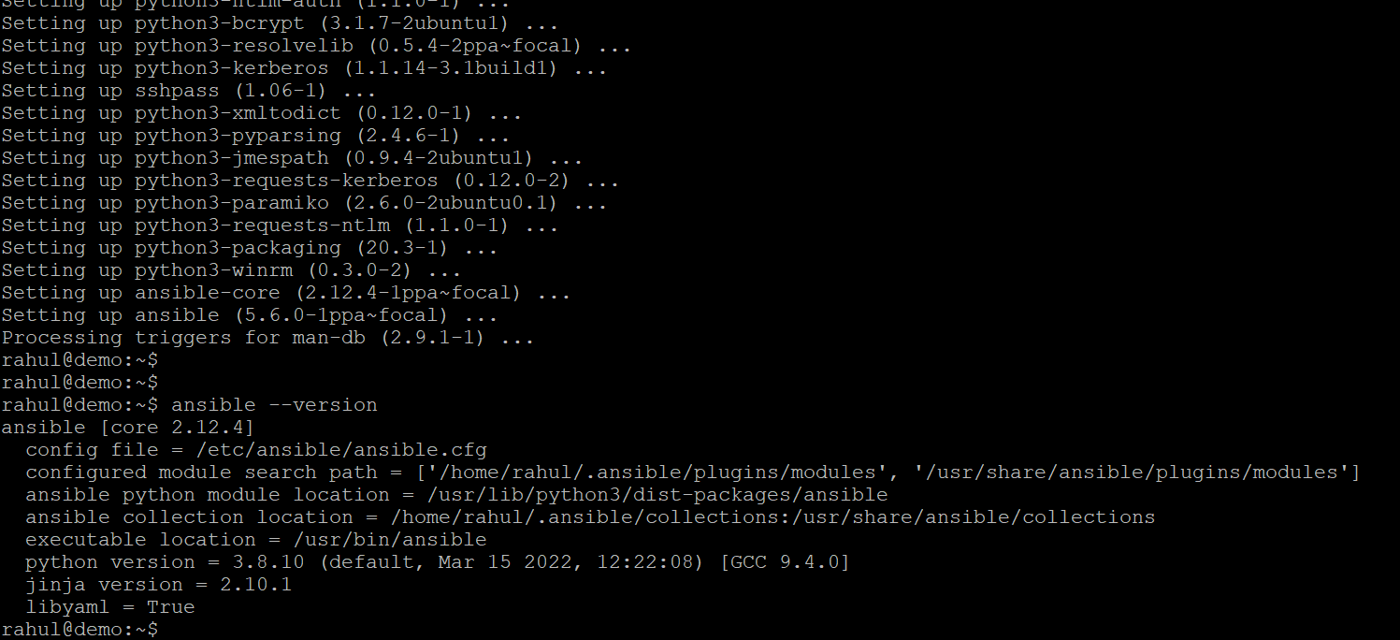

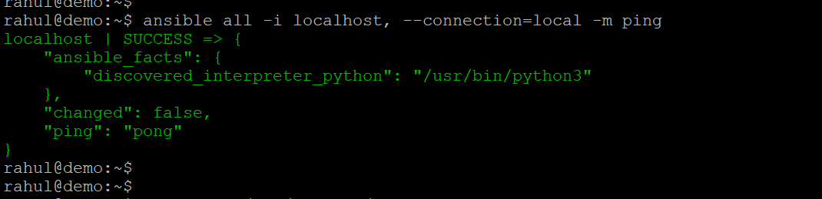

Configuring Ansible for the remote server



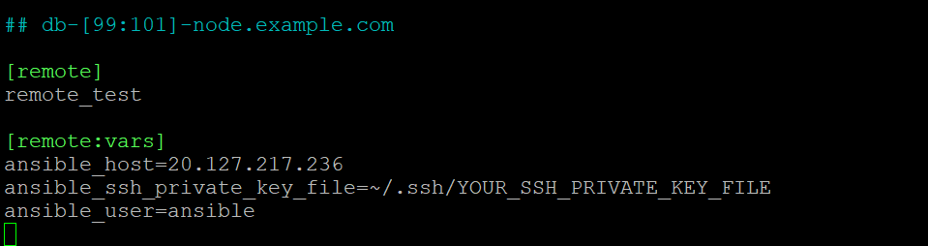

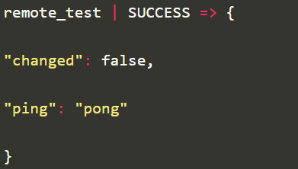

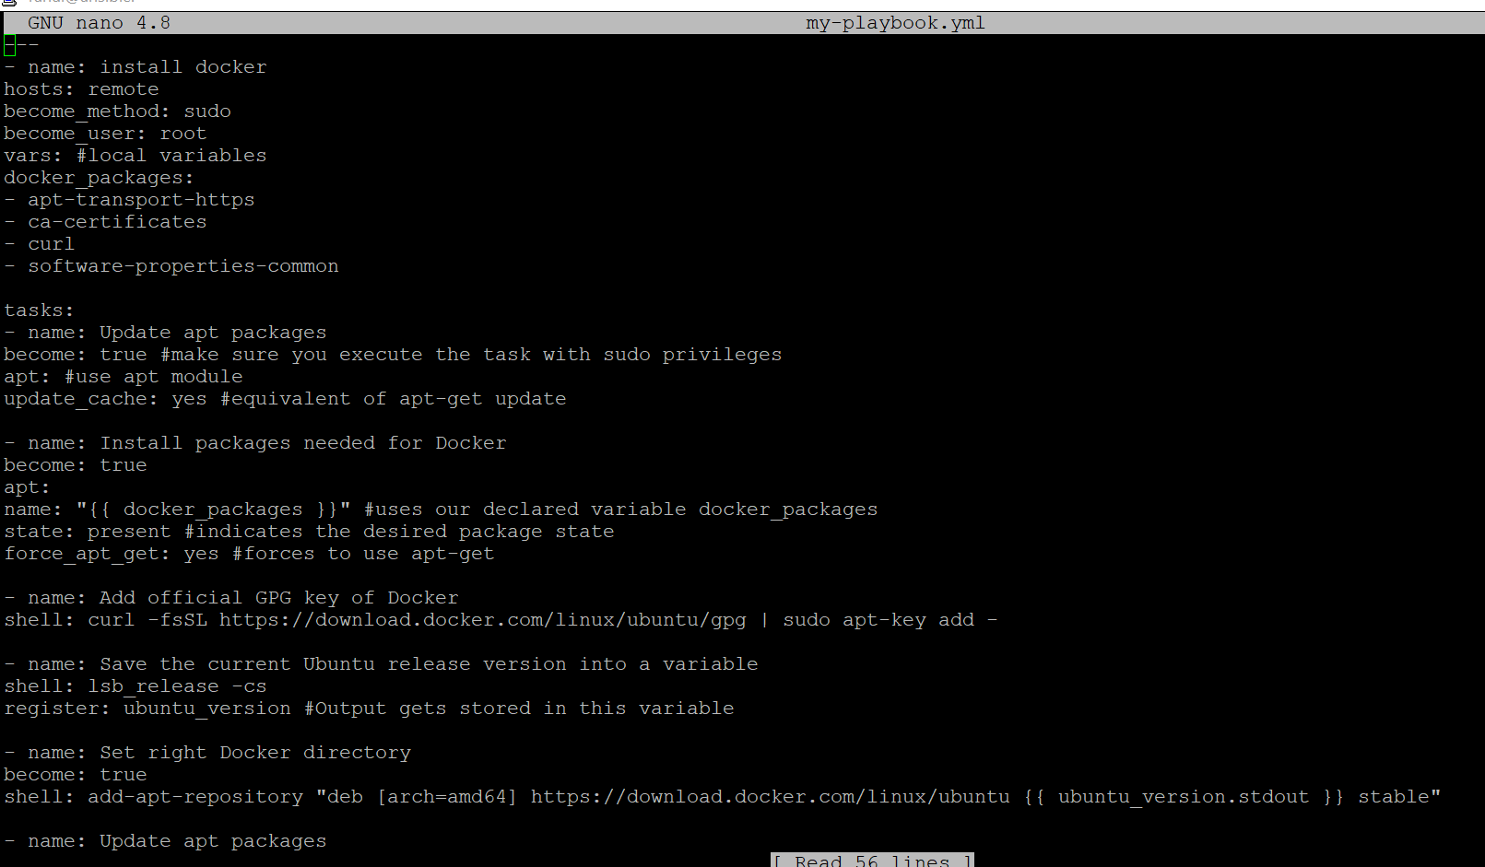

1. **Modify ansible.cfg to use hosts file as inventory**









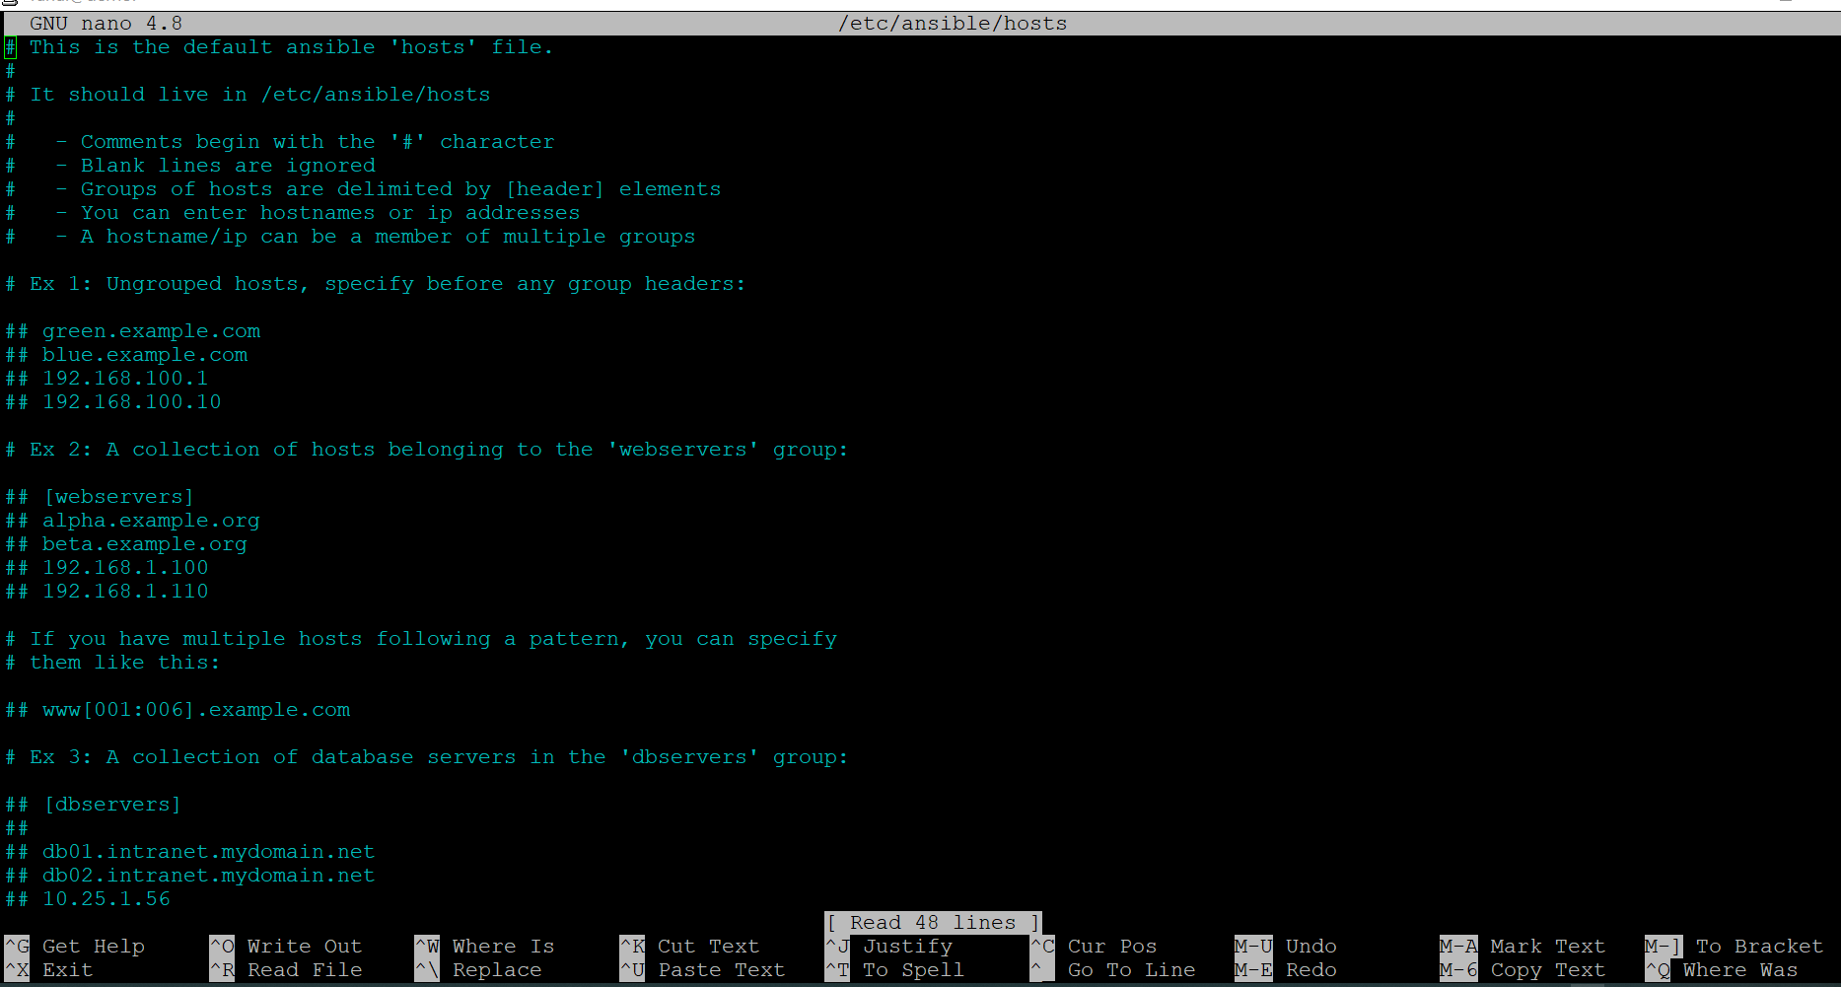

1. **install python-pip in ansible server**

root@Jenkins:~# apt-get install python3 python3-pip

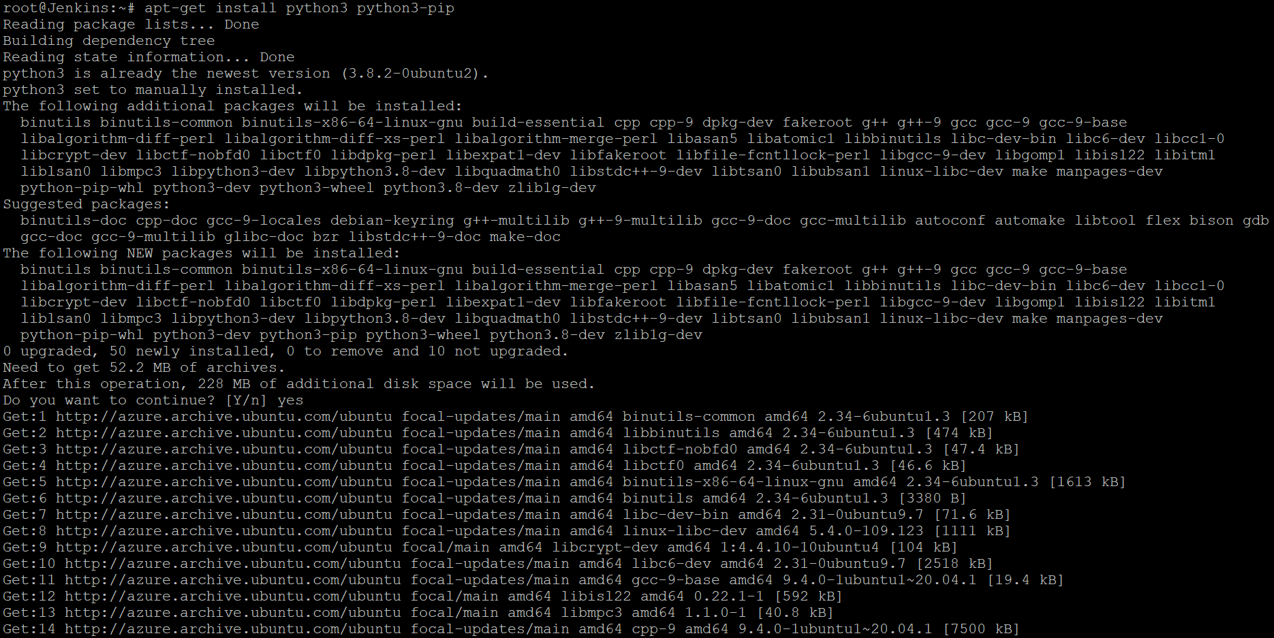

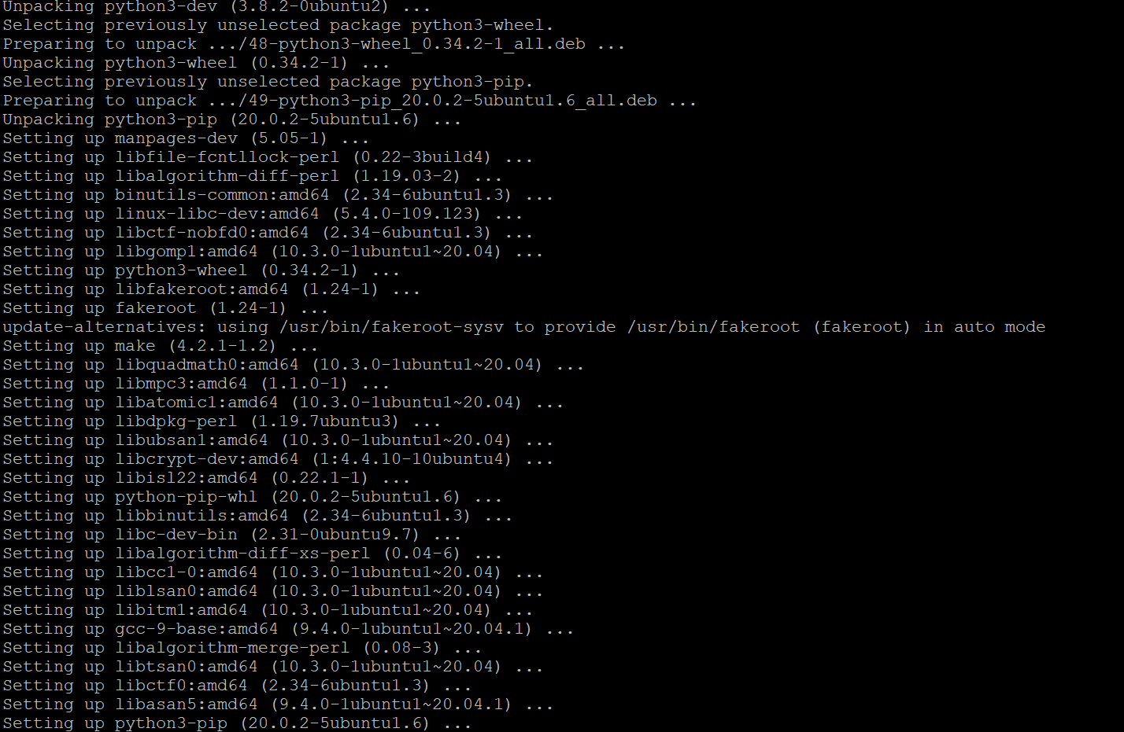

root@Jenkins:~# sudo pip3 install ansible

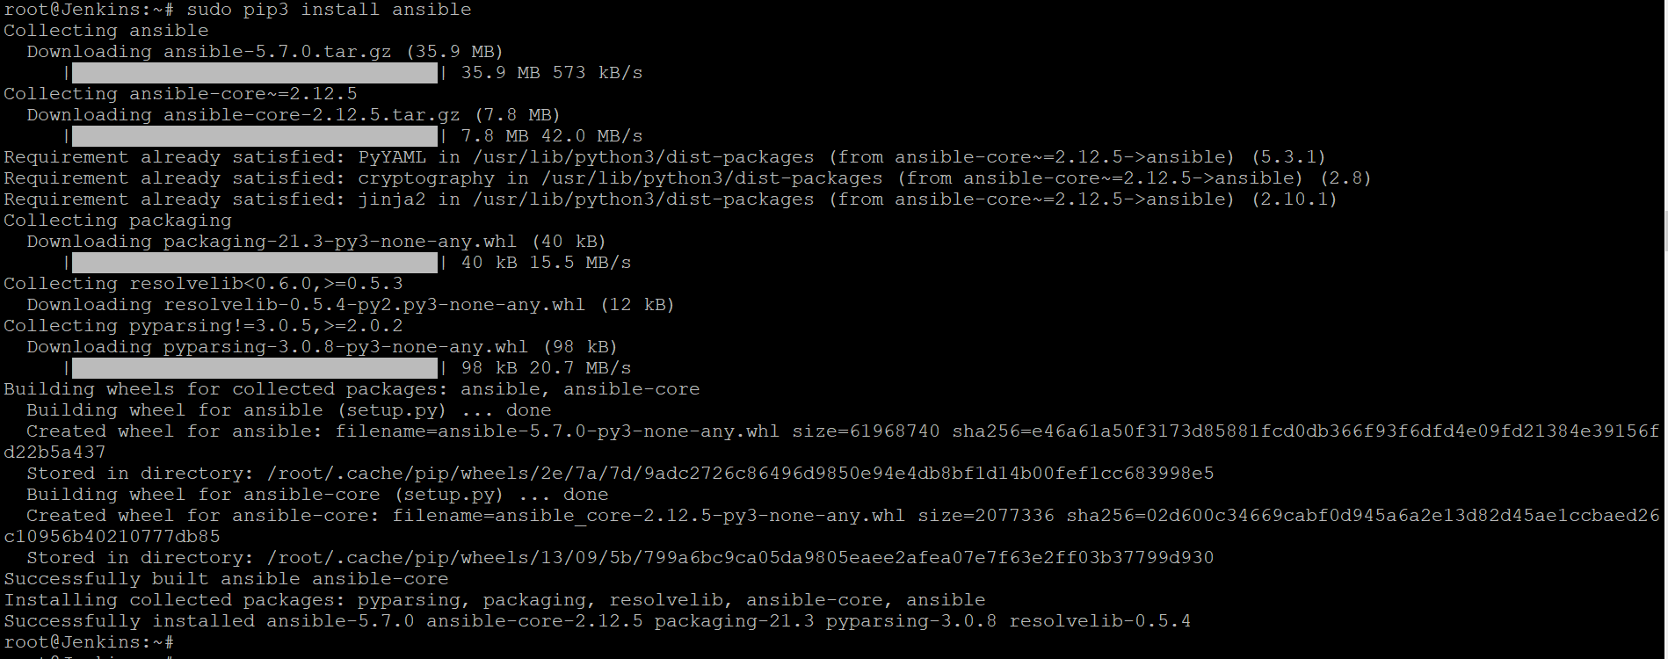

root@Jenkins:~# ansible --version

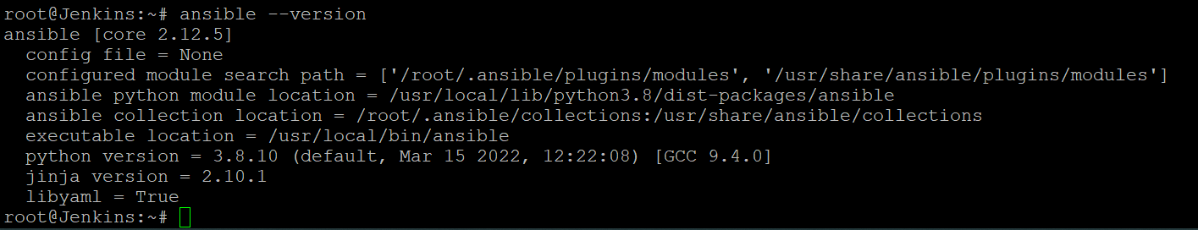

1. **Using PIP install azure modules in Ansible server**

sudo apt install python3-pip

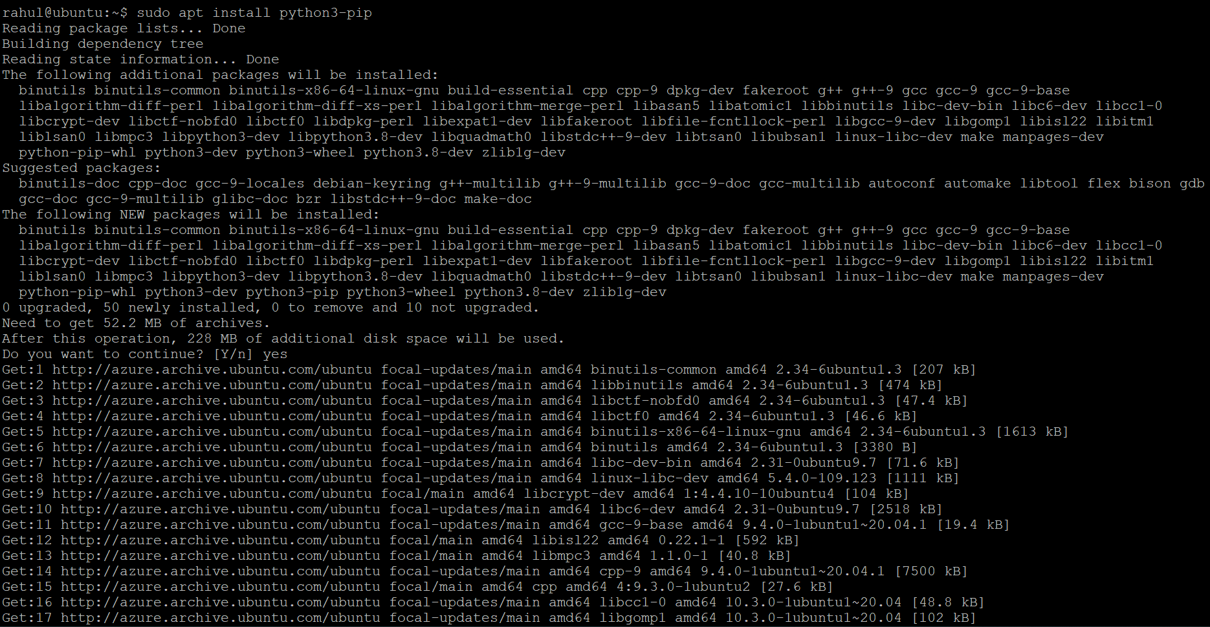

Install the pip library for Ansible-Azure

rahul@ubuntu:~$ pip install ansible[azure]

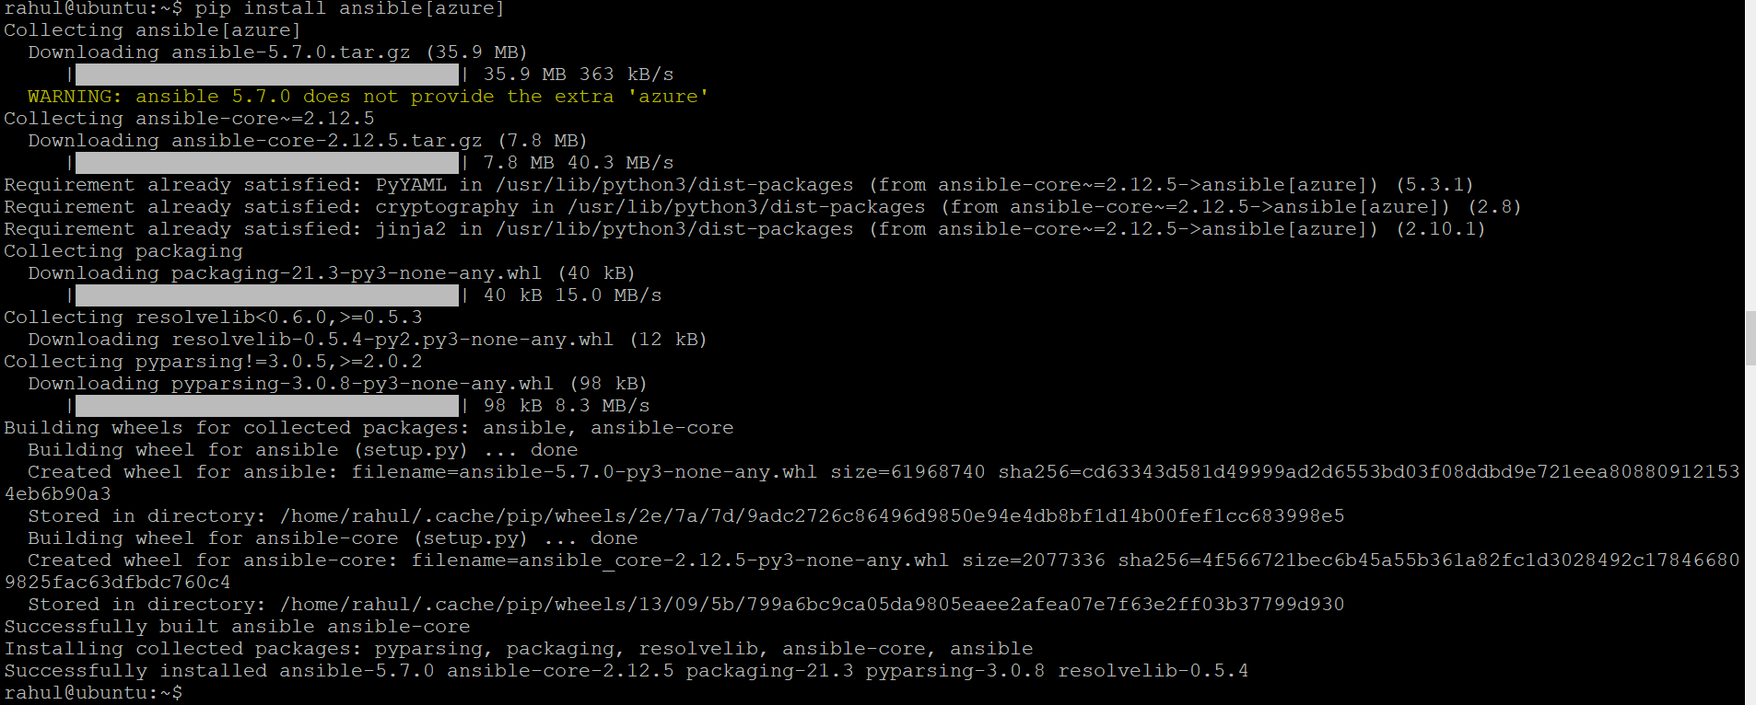

rahul@ubuntu:~$ sudo apt install ansible

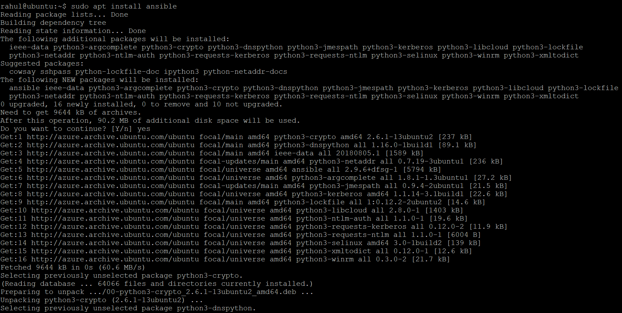

rahul@ubuntu:~$ ansible-galaxy install azure.azure_preview_modules

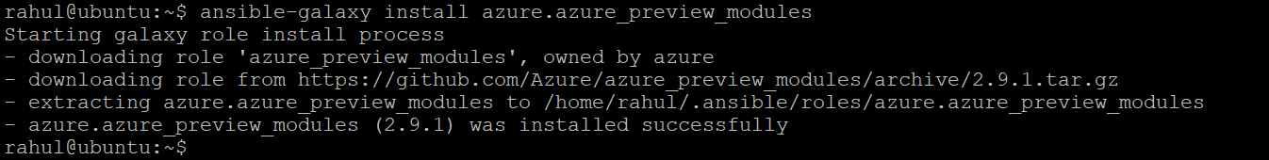

rahul@ubuntu:~$ pip install -r ~/.ansible/roles/azure.azure_preview_modules/files/requirements-azure.txt

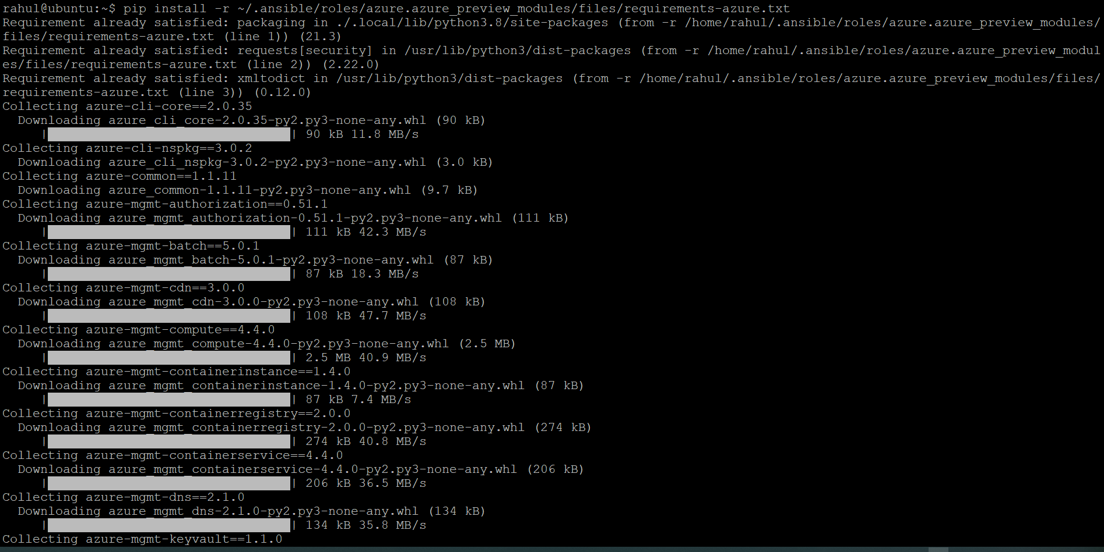

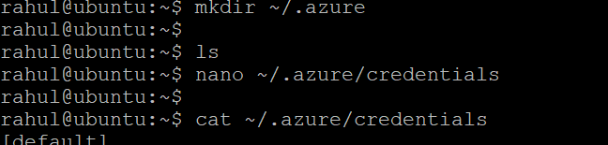

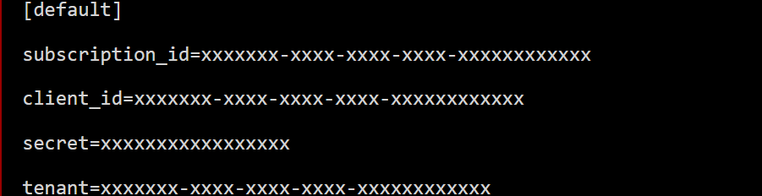



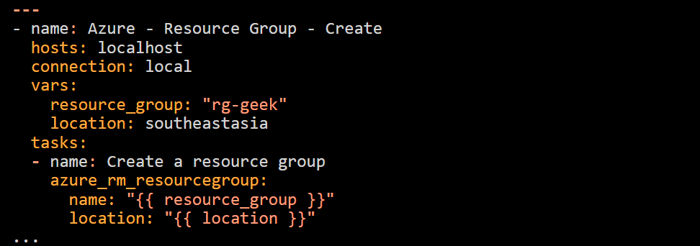

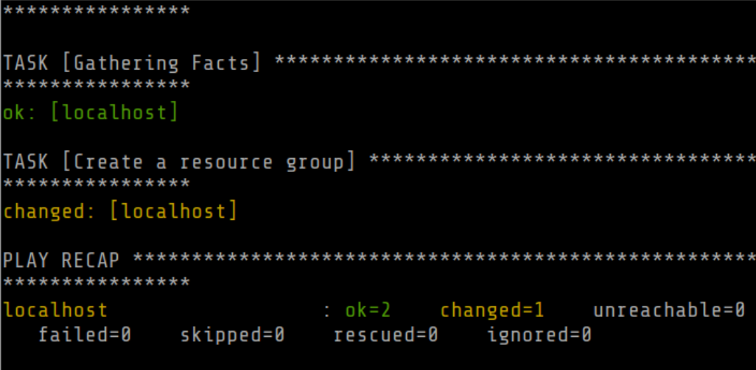

1. **Use the same service Principle created for terraform for ansible to get authenticated to Azure**

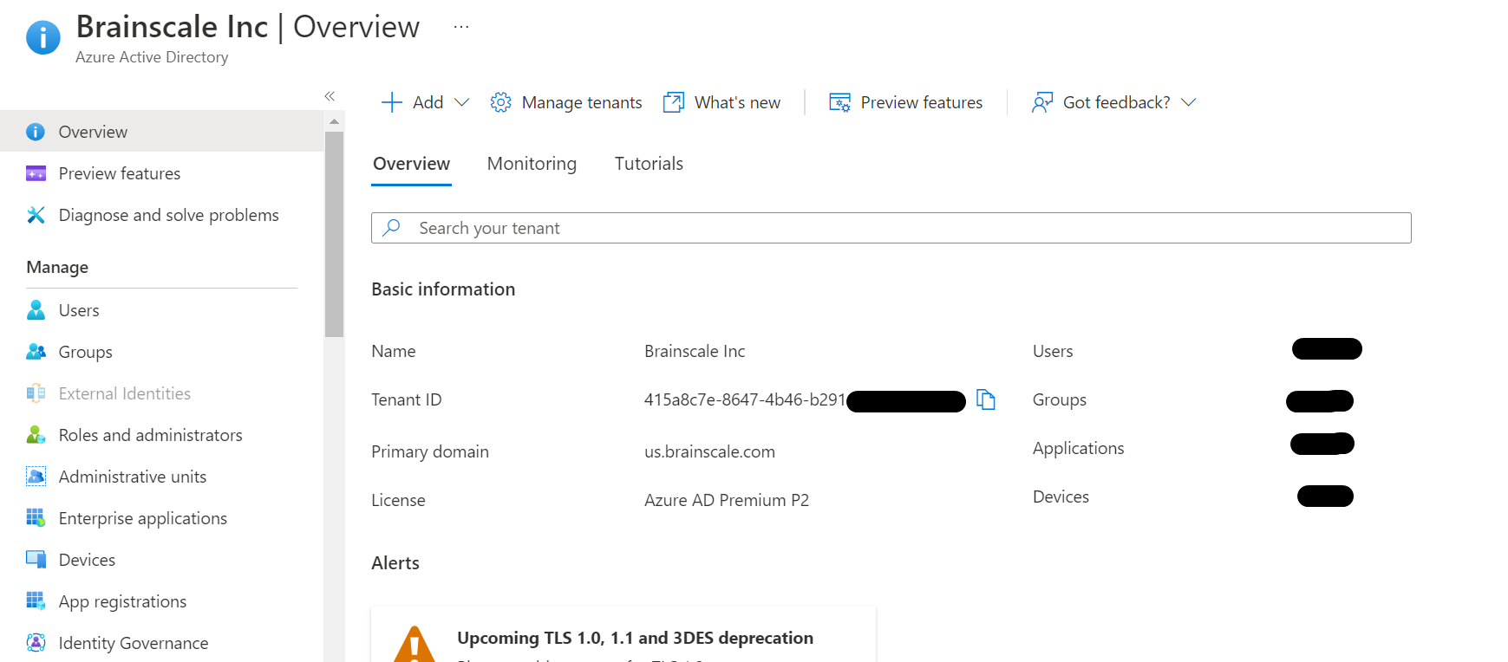

**Permissions required for registering an app**

You must have sufficient permissions to register an application with your Azure AD tenant, and assign to the application a role in your Azure subscription.

**Check Azure AD permissions**

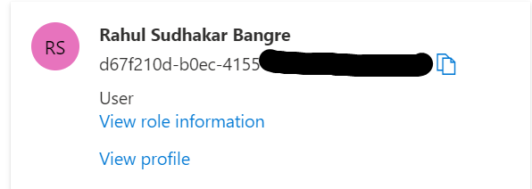

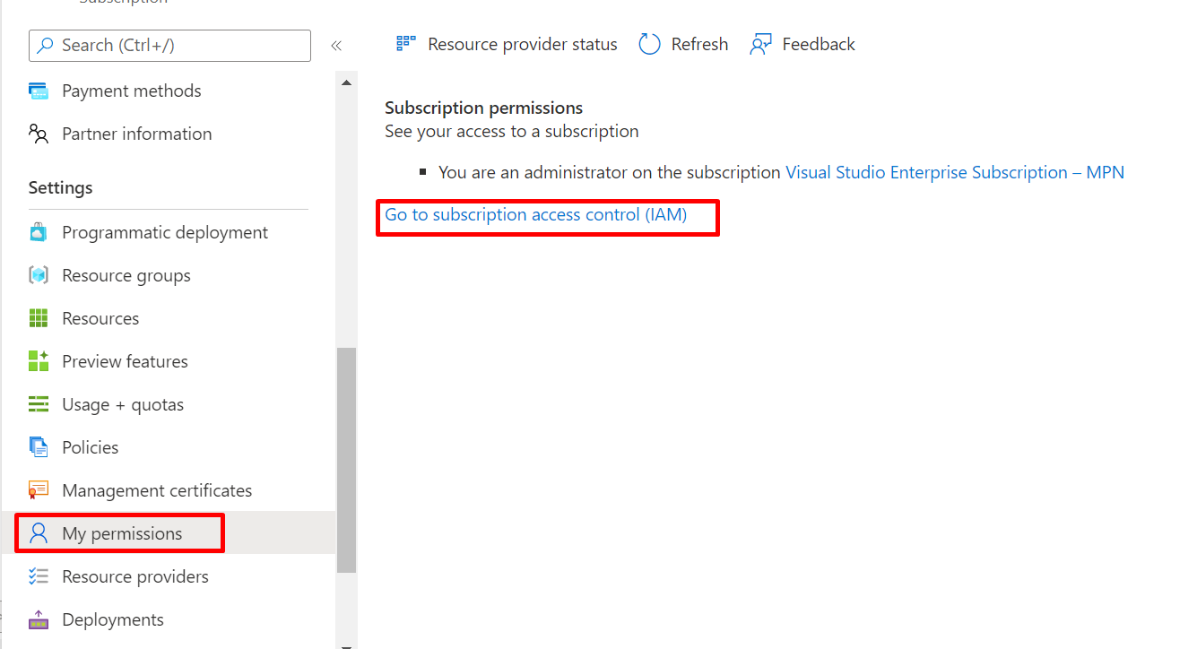

**Get tenant and app ID values for signing in**

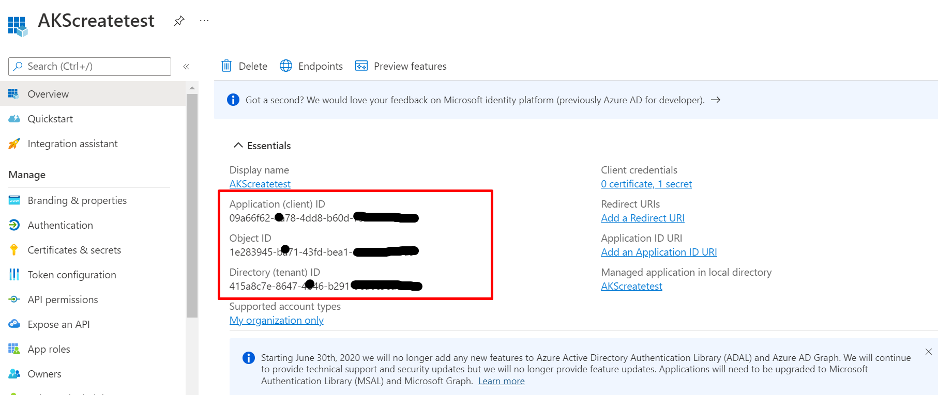

**Authentication: Two options**

here are two types of authentication available for service principals: password-based authentication (application secret) and certificate-based authentication. *We recommend using a certificate*, but you can also create an application secret.

**Option 1: Upload a certificate**

You can use an existing certificate if you have one. Optionally, you can create a self-signed certificate for *testing purposes only*. To create a self-signed certificate, open PowerShell and run [New-SelfSignedCertificate](https://docs.microsoft.com/en-us/powershell/module/pki/new-selfsignedcertificate) with the following parameters to create the cert in the user certificate store on your computer:

$cert=New-SelfSignedCertificate -Subject "CN=DaemonConsoleCert" -CertStoreLocation "Cert:\CurrentUser\My" -KeyExportPolicy Exportable -KeySpec Signature

**Option 2: Create a new application secret**

If you choose not to use a certificate, you can create a new application secret.

1. Select **Azure Active Directory**.
2. From **App registrations** in Azure AD, select your application.
3. Select **Certificates & secrets**.
4. Select **Client secrets -> New client secret**.
5. Provide a description of the secret, and a duration. When done, select **Add**.

After saving the client secret, the value of the client secret is displayed. Copy this value because you won't be able to retrieve the key later. You will provide the key value with the application ID to sign in as the application. Store the key value where your application can retrieve it.

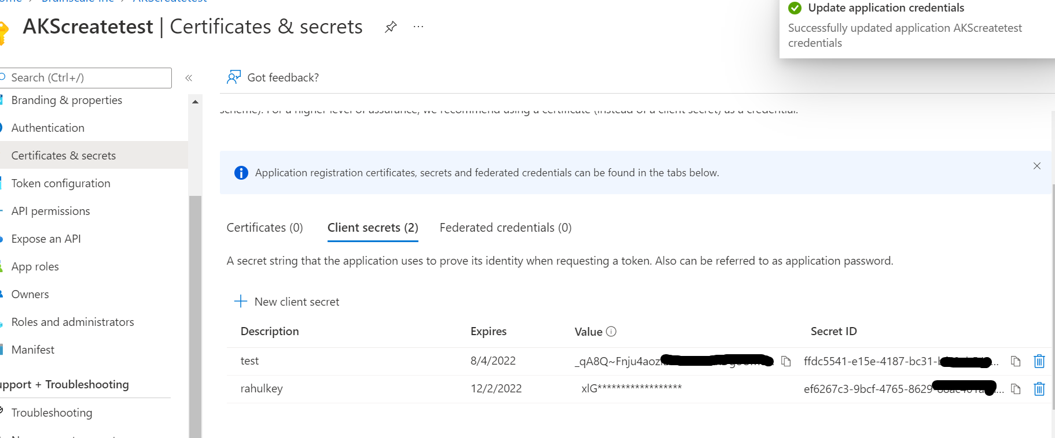

1. **Create a playbook1 to create aks cluster in azure and test**

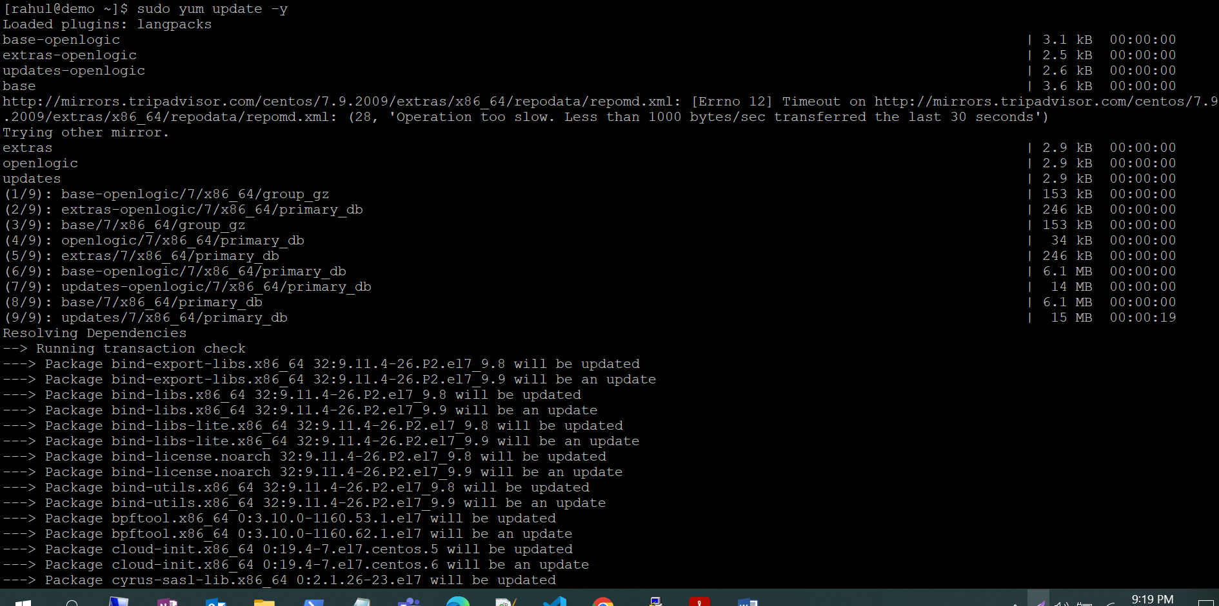

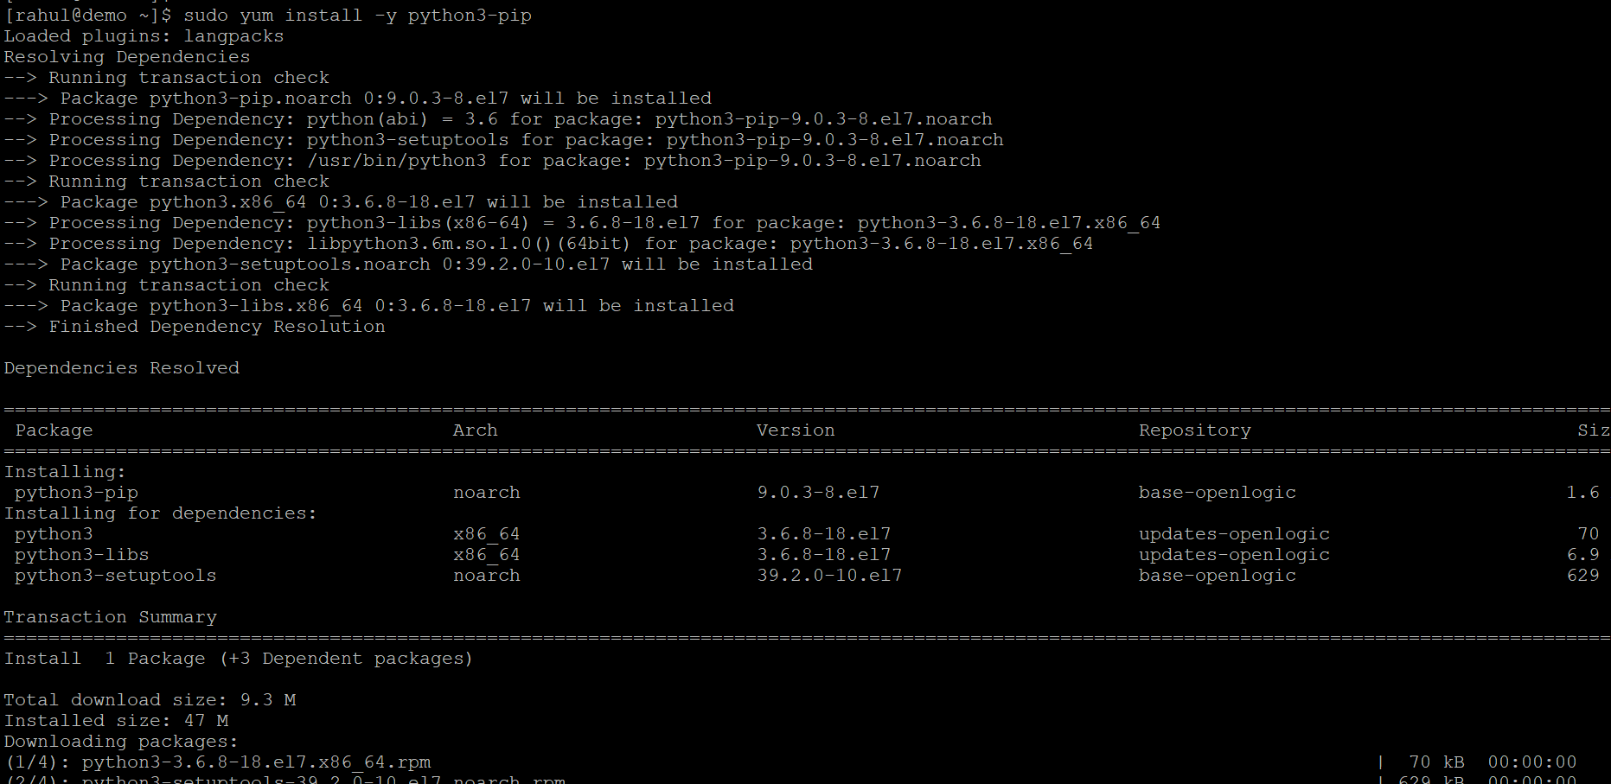

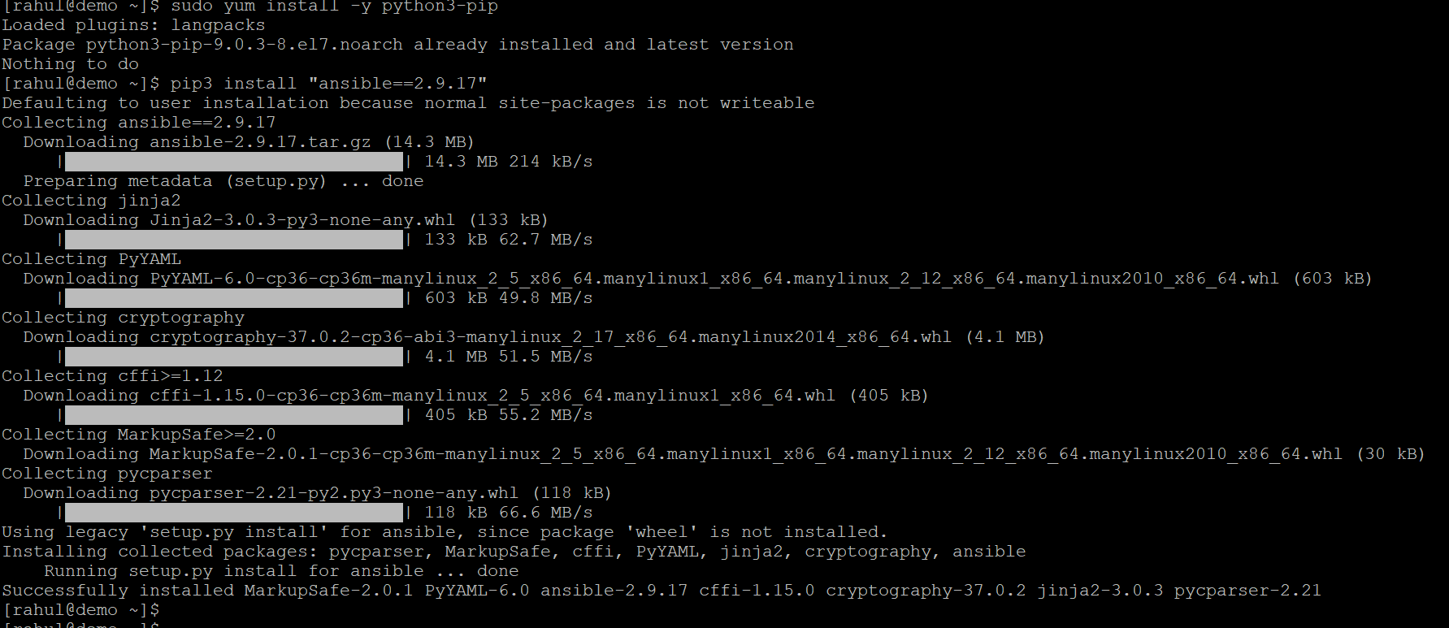

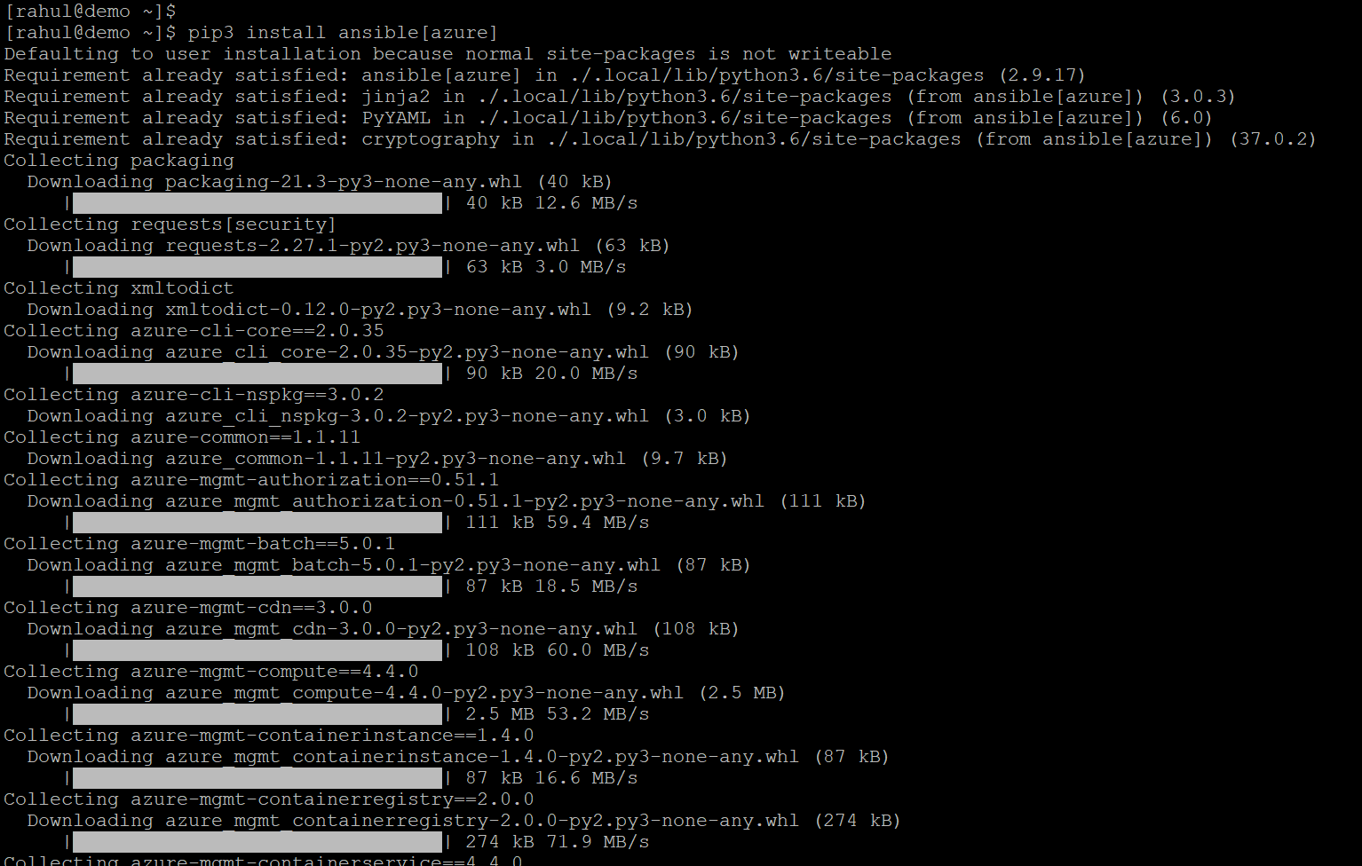

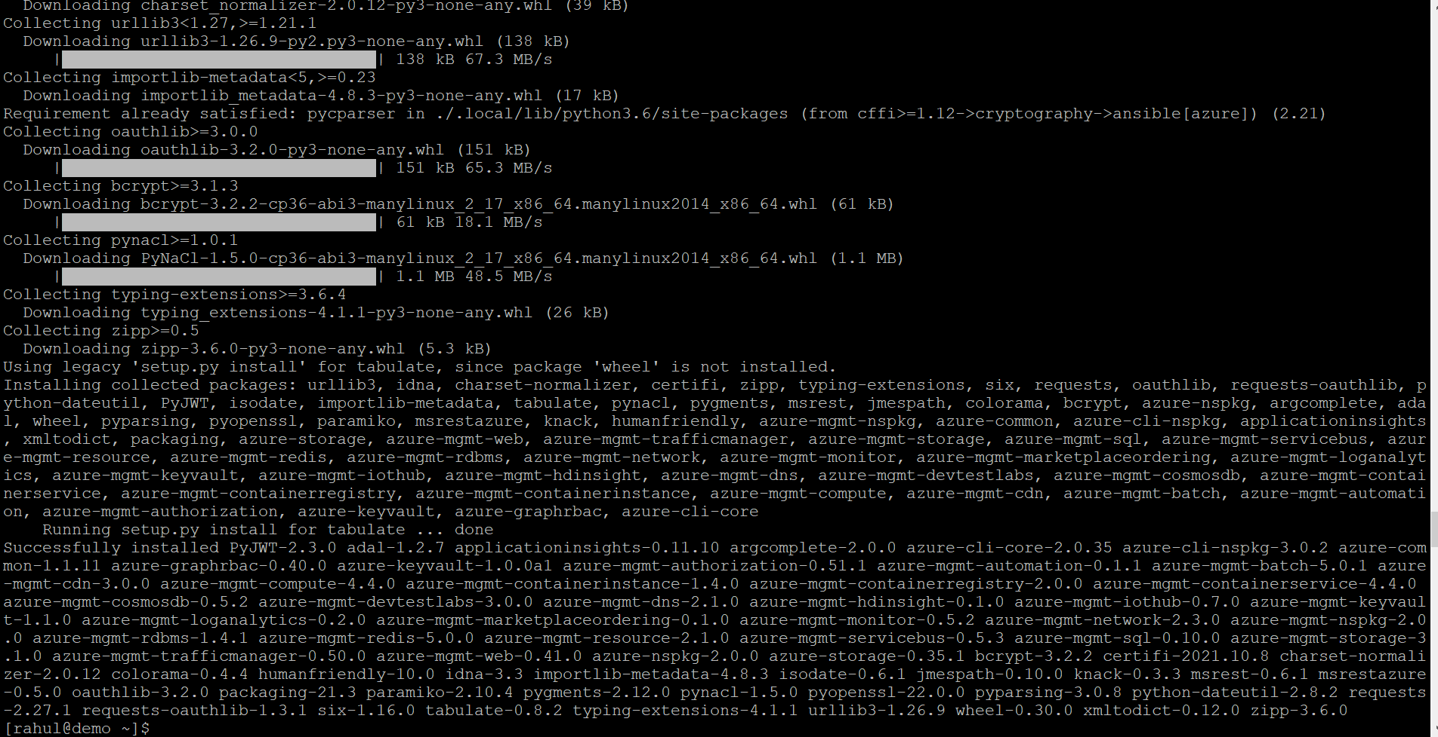

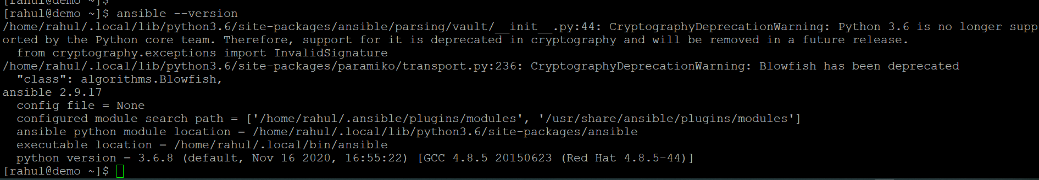

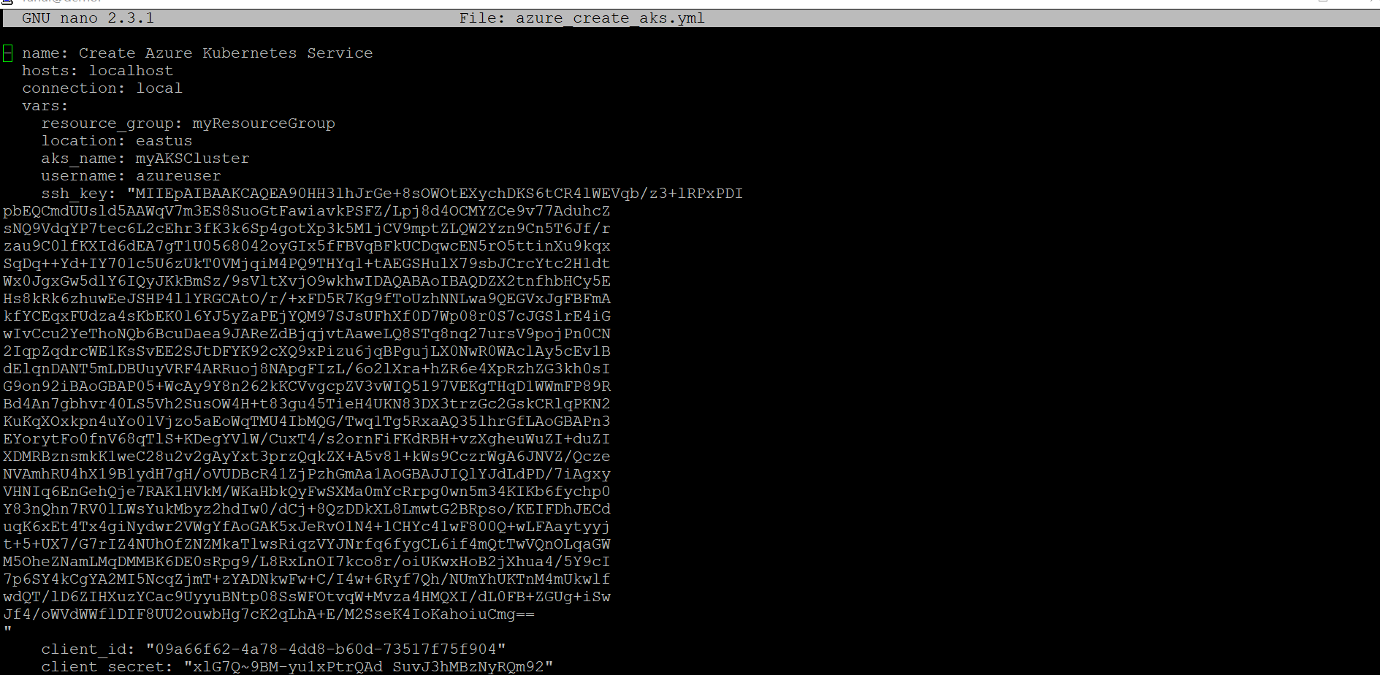

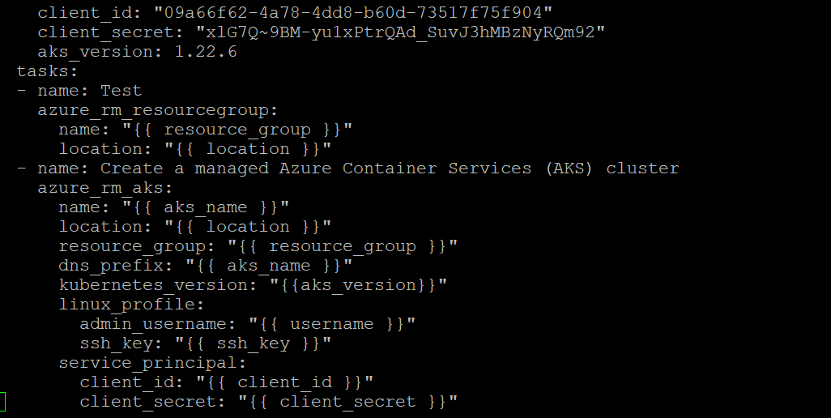

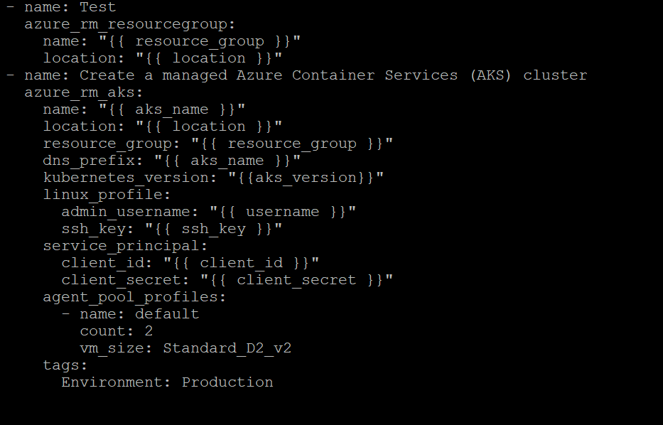

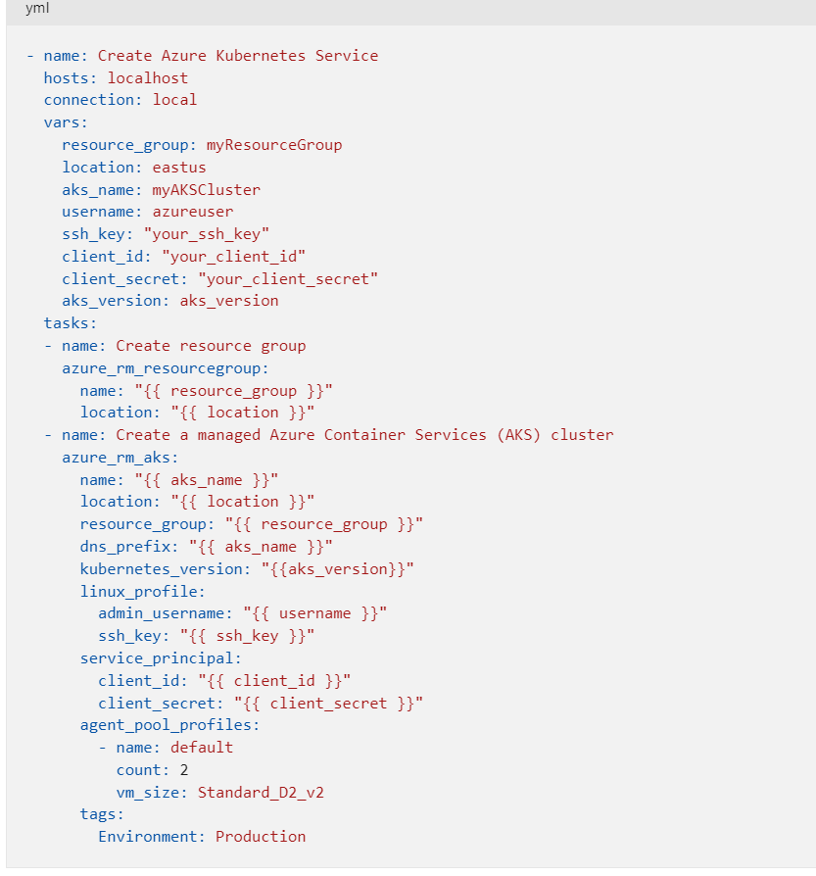

[rahul@demo ~]$ ansible-playbook azure_create_aks.ymls

